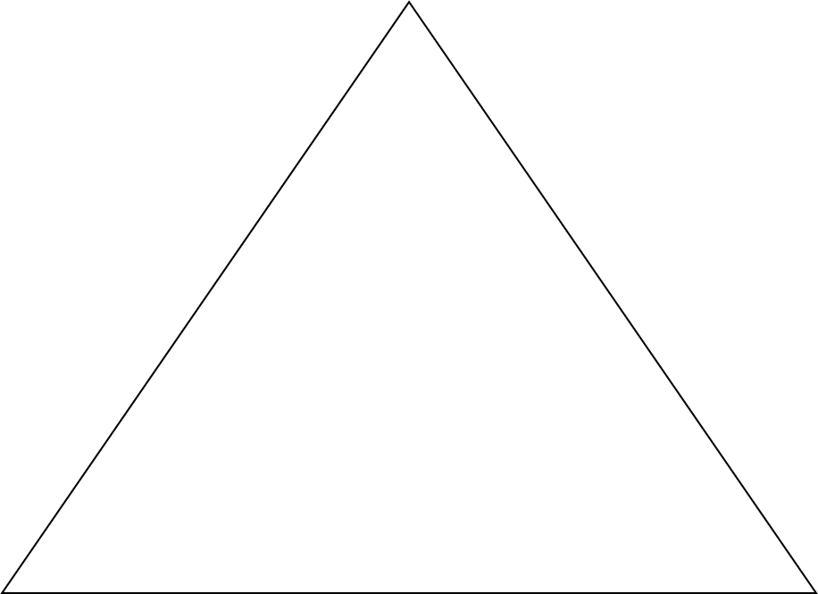

So What?

Summarize Essay:

Restate Thesis:

Background Info:

Thesis:

Hook/Grabber:

Specific🡪Broad

Broad🡪Specific

Conclusion

Introduction