How do American social boundaries affect a person's identity?

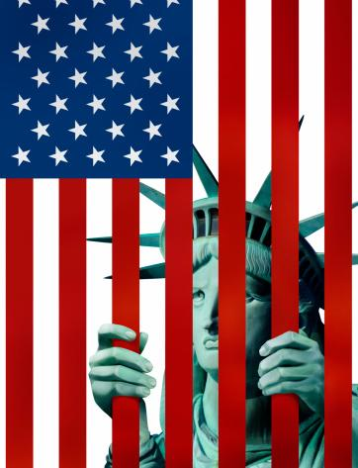

“Being an American is about having the right to be who you are, but sometimes that doesn't happen.”
-Herb Ritts

Document A
An excerpt from The Absolutely True Diary of a Part-time Indian
They stared at me, the Indian boy with the black eye and swollen nose, my going-away gifts from Rowdy. Those white kids couldn't believe their eyes. They stared at me like I was Bigfoot or a UFO. What was I doing at Reardan, whose mascot was an Indian, thereby making me the only other Indian in town?

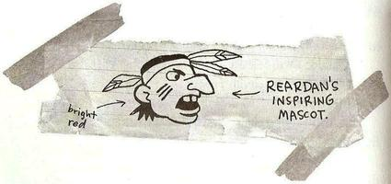

So what was I doing in racist Reardan, where more than hall of every graduating class went to college? Nobody in my family had ever gone near a college. Reardan was the opposite of the rez. It was the opposite of my family. It was the opposite of me. I didn't deserve to be there. I knew it; all of those kids knew it. Indians don't deserve shit. (Alexie 56)

Document Analysis

- What social boundaries are placed on the individuals in this document?

- How does the author characterize the individuals in the document? And how do the individuals overcome the boundaries?

- Identify what the author says, what the author really means, and why does that matter?

- How is this person being affected by society? List positives and negatives.

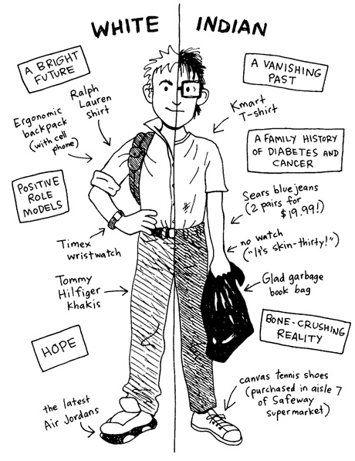
Document B
An excerpt from The Absolutely True Diary of a Part-time Indian

My full name is Arnold Spirit Jr. But nobody called me that. Everybody calls me Junior. Well, every other Indian calls me Junior.
“My name is Junior,” I said. “And my name is Arnold. It’s Junior and Arnold. I’m both.”
I felt like two different people inside of one body. No, I felt like a magician slicing myself in half, with Junior living on the north side of the Spokane River and Arnold living on the south. (Alexie 60-61)

Document Analysis

- What social boundaries are placed on the individuals in this document?

- How does the author characterize the individuals in the document? And how do the individuals overcome the boundaries?

- Identify what the author says, what the author really means, and why does that matter?

- How is this person being affected by society? List positives and negatives.

Document C
An excerpt from Mexican Whiteboy

And Danny’s brown. Half-Mexican brown. A shade darker than all the white kids at his private high school, Leucadia Prep. Up there, Mexican people do under-the-table yard work and hide out in the hills because they’re in San Diego illegally. Only other people on Leucadia’s campus who share his shade are the lunch-line ladies, the gardeners, the custodians. But whenever Danny comes down here, to National City--where his dad grew up, where all his aunts and uncles and cousins still live--he feels pale. A full shade lighter. Albino almost.
Less than. (de la Peña 2)

Angela and Bee comb Danny over with their almond-shaped eyes, devour his out-of-place surfer style like a pack of rabid dogs. Danny cringes at how different he must seem to his cousin’s friends. They’re all dark chocolate-colored, hair sprayed up, dressed in pro jerseys and Dickies, Timberlands. Gold and silver chains. Calligraphy-style tats. Danny’s skin is too clean, too light, his clothes too soft. (de la Peña 3)

He’s Mexican, because his family’s Mexican, but he’s not really Mexican. His skin is dark like his grandma’s sweet coffee, but his insides are as pale as the cream she mixes in.
Danny holds his pencil above the paper, thinking: I’m a white boy among Mexicans, and a Mexican among white boys. (de la Peña 90)

Document Analysis

- What social boundaries are placed on the individuals in this document?

- How does the author characterize the individuals in the document? And how do the individuals overcome the boundaries?

- Identify what the author says, what the author really means, and why does that matter?

- How is this person being affected by society? List positives and negatives.

Document D
An excerpt from Mexican Whiteboy

This is why sometimes he feels as out of place at his grandma’s as he does at Leucadia Prep.
And when his grandma passes out homemade tortillas, hot off the griddle, she does it based on family rank. It’s a subtle unspoken ranking system, but one each and every person in the house understands. And ‘cause he’s so guapo and gets such good grades and lives in such a better neighborhood these days-and ‘cause in a weird way Grandma’s almost ashamed of being Mexican-he’s always the first to eat. Even before his uncles. His dad when he was still around.
And sure, that’s when it seems like he belongs, but it’s more complicated than that.
His uncles and cousins may smile and nod and even crack on his some-“D-man, Li’l D, D-money, roll it up right, man, fold it at the end, here do like this, homey, with your fingers, don’t hold it like no white boy now or else the butter’s gonna drip right out the bottom, get all over your hand”-but all he wants to do is give that tortilla right back to his grams. Hold off till the next round. Have her offer that first one up to his dad instead. Or Uncle Ray. Or Sofia and Veronica. Uncle Tommy and his new wife, Cecilia. Even Veronica’s gangster boyfriend, Jesus. He’d just as soon wait till everybody in the house had one in their hand before he did.
And if people only knew how that felt. Having the whole family stare at him and his tortilla, these people he adores.
That’s when he wishes he didn’t get such good grades. When he wishes he lived even closer to the border than they did, in a one-room shack in the worst barrio this side of Tijuana. Dirt floors and no running water. When he wishes he got in more trouble at school, maybe a suspension on his record for fighting or bringing a switchblade to class. Maybe he could cuss out one of his private-school teacher in the hall during lunch: “I ain’t gotta listen to you, white bitch!”
‘Cause the very things Grandma gushes over are what shame him most. Such a good little boy. Such a pretty boy. Look at him doing all his homework before bed, studying for that big English midterm, taking out the trash without even being asked. Look at him writing letter after letter to his dad, even though his dad never even said goodbye to his bitch ass. (de la Peña 46-47)

Document Analysis
- What social boundaries are placed on the individuals in this document?

- How does the author characterize the individuals in the document? And how do the individuals overcome the boundaries?

- Identify what the author says, what the author really means, and why does that matter?

- How is this person being affected by society? List positives and negatives.
Document E

“Identity” by Julio Noboa Polanco

Let them be as flowers,

always watered, fed, guarded, admired,

but harnessed to a pot of dirt.

I'd rather be a tall, ugly weed,

clinging on cliffs, like an eagle

wind-wavering above high, jagged rocks.

To have broken through the surface of stone,

to live, to feel exposed to the madness

of the vast, eternal sky.

To be swayed by the breezes of an ancient sea,

carrying my soul, my seed,

beyond the mountains of time or into the abyss of the bizarre.

I'd rather be unseen, and if

then shunned by everyone,

than to be a pleasant-smelling flower,

growing in clusters in the fertile valley,

where they're praised, handled, and plucked

by greedy, human hands.

I'd rather smell of musty, green stench

than of sweet, fragrant lilac.

If I could stand alone, strong and free,

I'd rather be a tall, ugly weed.

Document Analysis

- What social boundaries are placed on the individuals in this document?

- How does the author characterize the individuals in the document? And how do the individuals overcome the boundaries?

- Identify what the author says, what the author really means, and why does that matter?

- How is this person being affected by society? List positives and negatives.

Document F
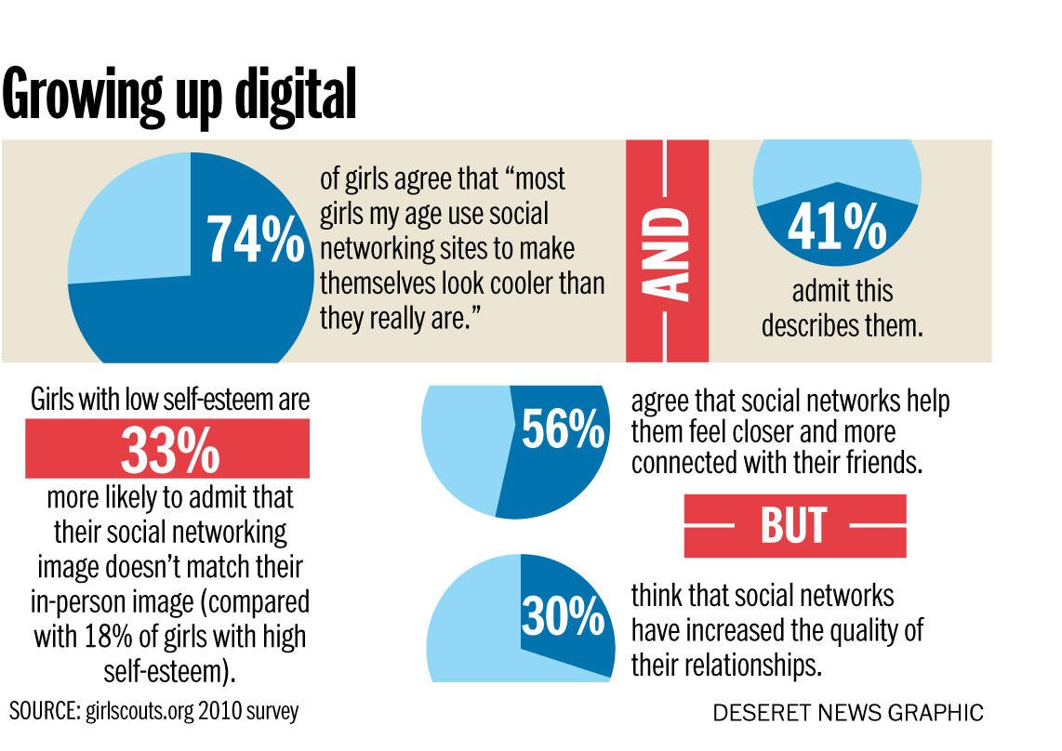

MEDIA Chandra Johnson Wednesday, May 28, 2014

Growing up digital: How the Internet affects teen identity

When British 14-year-old Hannah Smith turned to popular social networking site Ask.fm in July 2013, she wanted reassurance.
Stressed out from studying for exams and anxious about the return of eczema that made her feel ugly, Smith opened up about her feelings on the site, which allows users to pose questions others can respond to anonymously.
The responses came in rapid succession. Anonymous posters urged Smith to cut herself and drink bleach. One even said, “Do us all a favour n kill ur self."
When Smith did just that a month later, her father blamed the anonymity of Ask.fm's commenters for his daughter's death. The family demanded action against the site, and Smith's death made international headlines about the effects of cyberbullying.
What detectives found was arguably much more tragic — that Smith sent the hateful messages to herself, hoping her friends would rally in her defense.
While cases like Smith’s are rare, Smith was doing what most teenagers do: seeking identity validation from friends and strangers, often via social media. As a new generation comes of age online, the Internet could be affecting how they form their identity.

Catherine Steiner-Adair, a psychologist and author of “The Big Disconnect: Protecting Childhood and Family Relationships in the Digital Age,” says the kind of outside affirmation Smith sought online is a vital part of how teens form identity.
“The need for validation and confirmation that you’re OK is so huge,” Steiner-Adair said. “Parents often say, 'How could you go on a site where people can anonymously respond to whatever your question is: Am I cute? Am I fat?' But we’re forgetting what it means to be a teenager when we say things like that.”
Social media allow kids to broadcast everything while connecting them to experiences they might not have encountered a generation ago. But it also opens teens up to exponential ridicule or an amplified feeling of invisibility that can influence the perceptions they have of themselves.
According to market research data released this year from GFK, a German market research institute, the amount of time teens spend online has grown 37 percent since 2012, to about four hours a day. In a 2010 survey from the Girl Scout Research Institute, 74 percent of girls said they felt their peers used social media to "make themselves look cooler than they are," and 41 percent said that also describes them.
A 2010 study from York University found that people with lower self-esteem spent more time online and posted more "self-promotional" content to sites like Facebook.
Steiner-Adair says that while technology changed how teens seek and get feedback about identity, teen behavior is much the same.
“Kids are always looking at each other, comparing themselves to each other. The same thing that’s going on in the halls is going on online,” Steiner-Adair said. “The difference for teenagers today is that there’s an endless supply of people to whom they can compare themselves.”

Online vs. real-time identities
Experts like Steiner-Adair and Dr. David Greenfield say the fact that many teens view their online and real-time identities as identical can be a recipe for disaster.
The problem is impulse control, says Greenfield, an assistant professor of psychiatry at the University of Connecticut School of Medicine and founder of the Center for Internet and Technology Addiction. He says that because teens' brains aren't fully developed, they don't have the impulse control to understand the damage they can do online.
"This group doesn't differentiate. They see their real-time identity and their online identity as identical when in fact they're not," Greenfield said. "Along with that, there's now no delay between the urge to do something and the ability to broadcast it instantaneously. They do and say things online that they ordinarily wouldn't do because it doesn't feel real to them. But what you do in cyberspace follows you into real space."
When the online and real-time identities don't match — or when a hoard of anonymous commenters say they don't — it can get dangerous, Steiner-Adair said.
"Kids spend a lot of time crafting this identity that you hope people will respond favorably to," Steiner-Adair said. “When they feel desperate for feedback or curious in a risky way, social networking sites like Ask.fm play very much on the vulnerability of teens' and preteens’ desire to not only know what people think of them but their hopes that they’re seen as cool and their hunger for approval."

The struggle to differentiate
Technology can also make it more difficult to form an identity. There are more versions of "self" than ever before, which gives kids who may already be struggling to figure out who they are even more to juggle. In an interview with NPR, media theorist and author Douglas Rushkoff explained the feeling in a term he coined: “digiphrenia.”
“ ‘Digiphrenia’ is the experience of trying to exist in more than one incarnation of yourself at the same time. There's your Twitter profile, your Facebook profile, your email inbox,” Rushkoff said. “All of these sort of multiple instances of you are operating simultaneously and in parallel. And that's not a really comfortable position for most human beings."
In their effort to individualize on the Web, teens use different accounts in different ways, as researcher Katie Davis found out while co-authoring "The App Generation: How Today's Youth Navigate Identity, Intimacy and Imagination in a Digital World."
"There's this interesting dichotomy online where there's an emphasis toward identity consolidation and having this crystallized identity that is well-formed for many different audiences versus an increased opportunity to present different identities," Davis said, explaining that teens often adapt their online identities almost like creating a brand.
The focus on the external image detracts from the creation of a true identity, which Davis says takes serious meditation. "They're tailoring and promoting almost a branded 'self.' If you're all of your time projecting an identity externally, it crowds out the time you have for internal reflection."
The kind of self-promotion or expression varies depending on the network.
"If they're on Facebook, their identities are available for many different audiences to see. So that restricts how they can express themselves because they have to make sure it's OK for a wide audience," Davis said.
The natural urge to seek approval online can create a dependency on the Internet, Greenfield said. Because teens are digital natives, they have a higher likelihood for addiction. He says you can see it in the way teens handle their cellphones.
"[The phone] is so much more than a way of communicating," Greenfield said. "They would no more be out and about without a phone than they'd go without underwear. It’s become part of their identity on a social and cultural level."
Davis and Gardner call it "app-dependent behavior," and while it's rare, it's also a recent development. For example, if a young person has a homework assignment, he or she might go online to get the facts, but Davis said an app-dependent person would also look for analysis of those facts to use in a book report rather than thinking about it themselves.
The same sort of app-dependency rears itself in relationships, where some people rely on talking online rather than in person. Others might depend on Facebook input to make decisions as small as which movie to see or even to resolve personal or moral dilemmas.
"Their online lives and offline lives are both real to them, and they do move fluidly between the two," Davis said. "But I think some young people who become very highly involved in an online community may have a harder time integrating that identity into the real world."
Read more at http://national.deseretnews.com/article/1553/Growing-up-digital-How-the-Internet-affects-teen-identity.html#RXIShdhlJFHqHAwl.99

Document Analysis

- What social boundaries are placed on the individuals in this document?

- How does the author characterize the individuals in the document? And how do the individuals overcome the boundaries?

- Identify what the author says, what the author really means, and why does that matter?

- How is this person being affected by society? List positives and negatives.

Informational Essay

Based on the documents that you have analyzed from the LBQ packet, think about each and how they address the boundaries that others have placed on them.

- Choose one document from each category (1 fiction from Mexican Whiteboy, 1 fiction from The Absolutely True Diary of a Part-Time Indian, the poem, and the news article) that exemplifies the boundaries that affect one's identity. Identify what social boundaries are addressed in these 4 documents that you have chosen.

Document: Document: Document: Document:

What social boundaries should be placed in each bucket from each document?

- Use the documents that you have selected and your list of social boundaries from part A to create a constructed response that answers: How do American social boundaries affect a person's identity? Textual evidence from each document you have chosen is a requirement. Your essay should be 4-6 paragraphs long and follow Standard English grammar and spelling.

