“Coming of Age in Changing Times” Choice Board (Week 5)
Rationale: Your job is to chronicle what you are seeing and hearing on the news, among your friends, within your family, and in your community as you come of age in this changing time. This is an important project that may be shared with your friends, family, and even future generations.
Directions for week of April 20 - April 24:
- Choose one assignment from each category (creative, writing, reading) to complete.
- Upload your 3 assignments to Floop by Friday, April 24th.

Creative  Choose one to complete. | Writing  Choose one to complete. | Reading  Choose one to complete.
How-To Video  How to video: Create a video teaching the audience how to do something. This may or may not be COVID-19 related. You can show how to wash hands effectively, how to sew a face mask, how to do a home workout, start a new hobby, etc. You can record the video on Flipgrid, on your phone camera, or with another program. | Journal Entries  Complete 2 journal entries, choosing from the prompts below:  - What were your feelings/thoughts/fears during our last day in school this year, March 13th?  - How do you stay connected digitally to other people, or do you prefer the alone time to reflect, or is it a mixture of both? Explain.  - What life skill have you learned this week? What new things have you been doing?  - Detail how your life has changed due to our current situation. How has life changed or stayed the same? | Short Film Analysis  Watch Hyper-Reality and Strange Beasts. Write a paragraph describing the role of technology in the short films. Is technology helpful or harmful in each of the short films? Why? Use details and examples from the films to support your answer.
Photo Story  Create a photo story/essay about what it means to come of age during the Coronavirus Pandemic. Use at least five photos with captions. | Letter to Workers  Write a 2-paragraph letter to our essential workers (hospital workers, police officers, firefighters) thanking them for their service and explaining how important they are during this pandemic. | Article Summary  Read the article and respond to the prompt: choose a problem (and solution) described in the text. Explain what the problem is and why it matters, using examples, facts, and details from the text. If possible, describe any solutions proposed in the text.

Utopian City  Create your own “Perfect World,” a utopian society. What will this world look like? Where do people live? How does the government distribute money? Create a map of your city. Write a one paragraph explanation of how your city runs. Why did you pick and choose certain parts? Is your city problem-free? If not, how will you solve those issues? | Letter to Self  Write a 2-paragraph letter to your younger self. If you could go back in time, what advice would you give yourself? What would you tell yourself to better prepare for this changing time you are now living in? What would you have done differently if you had known this was going to happen? | Short Story  Read “The Pedestrian” by Ray Bradbury and answer the following questions:  - Where are all of the other people in the city? What are they doing at night?  - What was Mr. Mead’s “crime”?  - Where do you think the police car took Mr. Mead at the end?  - What is a theme of the story?
Scene Reenactment  Film a reenactment of a scene from the “The Pedestrian” by Ray Bradbury. You could do a puppet show, create a video animation, or act it out. | Reliving your Childhood  What are your favorite childhood books (e.g. Charlotte's Web, Curious George, Pete The Cat, etc.)? Choose one and describe how you might update or reimagine the plot, characters, setting or conflict in some new way that reflects our contemporary world. Write about how the story would be different. | Article Analysis  Read the article and respond to the prompt: Write a short paragraph that explains the central idea of the article. Use at least two details from the article to support your response.
Incredible Talents  We want to know what you have been up to at home. Show us the creative ways you have entertained yourself during the shelter in place. Share with us any of the incredible talents that you have discovered during this time. This can include TikTok, Instagram, YouTube video, etc. | Creative Writing  What story does this image tell? Use your imagination to write the opening of a short story or poem inspired by this illustration — or tell about a memory from your own life that this picture makes you think of.  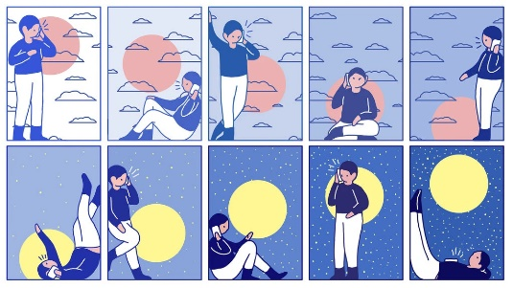 | News Analysis  Find a relevant, credible news article of your choosing. What was the article about? Why did you choose this article? What did you learn as a result of reading this article?

